**My Hero is You**

**how kids can fight COVID-19**

**Worksheet**

Suggested Key Stage: KS2

1. **Pre-reading activity:**

Think about the following questions and write your ideas in the spaces provided. Then share your ideas with your partner.

1. Do you have a hero/superhero in mind? Who is he/she?

|  |
| --- |
|  |
|  |
|  |

1. What are their super powers?

|  |
| --- |
| e.g. He can fly. He rescues people from danger. |
|  |
|  |

1. The book is called “My Hero is You”. Who do you think is the hero in the book?

|  |
| --- |
|  |
|  |
|  |

1. **While-reading: First reading**

COVID-19 is spreading around the world. Listen to your teacher’s reading of the story and find out the following:

1. Who are in the story?
2. What **problems** did they face because of COVID-19 and how did they **cope with the problems**?

You may also click the link to listen to the story: <https://www.youtube.com/watch?v=V29jbjPlEUA>

|  | **Character** | **Problem** | **Way to cope with problem** |
| --- | --- | --- | --- |
| (A) | **Sara and her ___________** | 1. Sara’s__________ is a scientist, but she cannot find a _________ for the coronavirus. 2. Sara was upset because the virus was affecting her life. | 1. She asked Sara to take good care of herself and stay safe, so that she could focus on her work. 2. Sara decided to tell all the children in the world how to _________ themselves so that they could protect everyone else. |
| (B) | **__________** | 1. COVID-19 was affecting his life. 2. The city he lived in was __________ but not everyone stayed at home. 3. He missed the people he loved a lot, including his grandparents. | 1. In order to protect himself, he stayed at least _______ metre away from people, washed his hands with _________ and water. He also coughed into his elbows if needed and _________ to people instead of shaking hands. 2. He flew across the city with Ario and Sara to tell everyone to stay __________. 3. He chatted with grandparents on the ___________ and shared what he did every day. |
| (C) | **_____________** | He felt scared sometimes. | When he felt scared, he breathed very ___________ to calm down. |
| (D) | **_____________** | 1. Her ____________ was sick and she was worried that she might spread the virus. 2. She sometimes argued with her family because they stayed together all the time at home. | 1. She did the following in order not to spread the virus:  * keeping a distance from people * using ___________ to show her care instead of hugging people * staying home  1. She had to be extra ____________ and extra understanding, and quick to say “sorry”. |
| (E) | **__________** | She was afraid of the virus because people might die from it. | She followed Ario’s advice by imagining a ___________ place in her mind. This helped keep her calm and relax. |
| (F) | **__________** | He had the virus himself and had recovered from it. | He kept a distance from his friends who cared about him. He believed that the most important thing friends could do was to ____________ each other. |

1. **While reading: Second reading**

Read the story again and understand more about the four heroes, Salem, Sasha, Leila and Kim by thinking about the following questions:

1. Where did they live?
2. What were their super powers?

|  |  |
| --- | --- |
| Questions | Character: Salem |
| Where did Salem live? | He lived near a _______________ next to pyramids. He probably lived in a Middle East country called Egypt. |
| What were his super powers? | * He knew how to protect himself and others from catching the virus. * He was eager to remind the people in the city to take care of each other best by staying _________________. * He cared about his ________________ by talking with them on the phone every day.   Use two adjectives to describe Salem.  ____________________________________________ |

|  |  |
| --- | --- |
| Questions | Character: Sasha |
| Where did Sasha live? | She lived in a small ____________. It was a place in the countryside, where there were green trees, beautiful flowers, and birds flying in the sky. |
| What were her super powers? | * She knew a lot about social distancing. * Her father was sick and she had to stay home to __________ sharing the virus with others. * Although she was on wheelchair and unable to _________, she stayed positive and enjoyed her life with her family even though they had to keep a distance from others. * She had great patience and was willing to apologise when she made a mistake.   Use two adjectives to describe Sasha.  ____________________________________________ |

|  |  |
| --- | --- |
| Questions | Character: Leila |
| Where did Leila live? | She lived in a camp which provided a temporary shelter for the homeless people. |
| What were her super powers? | * She knew how to keep herself safe from the virus. * She could cope with her ________ by imagining a safe place in her _________. * She gave support to her friends and joined Sara and Ario in the journey to make people know more about COVID-19.   Use two adjectives to describe Leila.  ____________________________________________ |

|  |  |
| --- | --- |
| Questions | Character: Kim |
| Where did Kim live? | He lived in a small town, which was near a snowy ___________ and a ___________. |
| What were his super powers? | * He could stay positive although he once had the coronavirus. * He had some good friends. They cared about each other. They understood that staying away from each other for a while could ______________ each other.   Use two adjectives to describe Kim.  ____________________________________________ |

1. **The key message of this story is “heroes come in all shapes and sizes”. In short, anyone can be a hero, including ourselves. The super powers of the characters are in the boxes below. Explain the super powers by giving more details.**

2) Show our love and care to our friends and relatives by:

____________________________

____________________________

____________________________

1. Know how to protect ourselves from COVID-19:

* _____________________________
* _____________________________
* ____________________________
* _____________________________

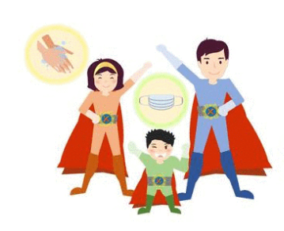

3) Sometimes, to protect our friends and family members, we have to:

____________________________

____________________________

4) Be extra patient and understanding by:

________________________________

________________________________

________________________________

5) Be brave to share our worries and stay calm:

* ___________________________

___________________________

* ___________________________

___________________________

1. **Reread Part 3 of the story “Sara and Ario met Salem” and underline the features of the story.**

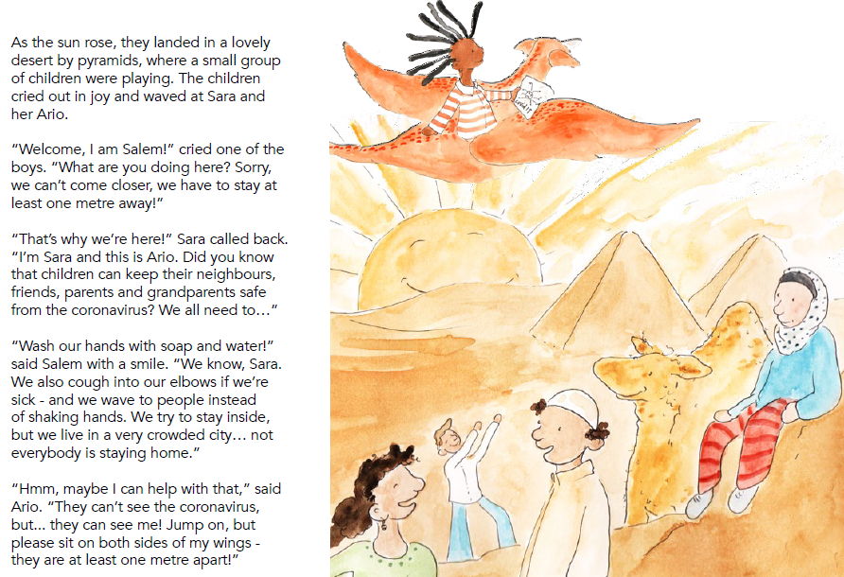

**Characters:** Who did they meet?

**Plot:** What did they say/ What happened?

Use **dialogues** in stories and make use of the present tenses wherever appropriate:

e.g. “Welcome, **I am Salem!”** cried one of the boys. **“**What **are you doing** here?”

The **simple past tense** to write about things that happened:

e.g. The children **cried** out in joy and **waved** at Sara and Ario.

The **past continuous tense** to show an ongoing past action which was happening at a specific moment:

e.g. As the sun rose, they landed in a lovely desert by pyramids, where a small group of children **were playing**.

Grammar items and language used in the story

**Problem:**

What problem did the character face?

**Setting:** Where did the story take place?

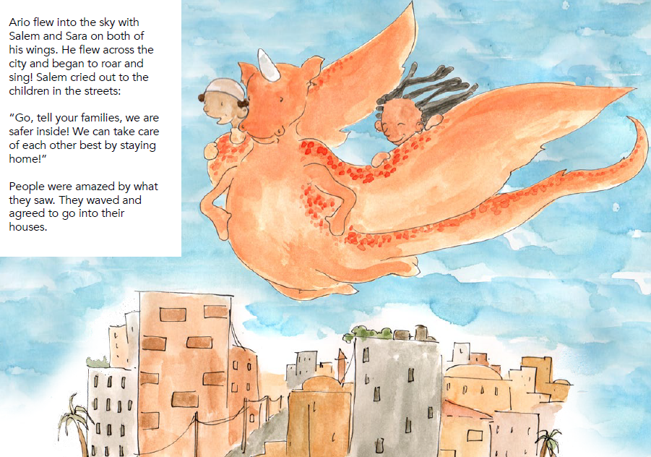

Use **adjectives** and **action verbs** to describe feelings:

e.g. The children **cried out in joy** and waved at Sara and her Ario.

e.g. People were **amazed** by what they saw. The **waved** and **agreed** to go into their houses.

**Solution:** How did they solve the problem?

Use the **imperatives** to give advice:

e.g. “**Go**, **tell** your families, we are safer inside!”

1. **Writing task:**Sara and Ario visited Hong Kong one night. Write about one of the scenes below and include the following:

* problems people faced during the COVID-19 pandemic, and
* share your advice / positive message with the people you met and help them fight COVID-19.

in a restaurant

at your school



at a park

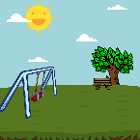

in a hospital

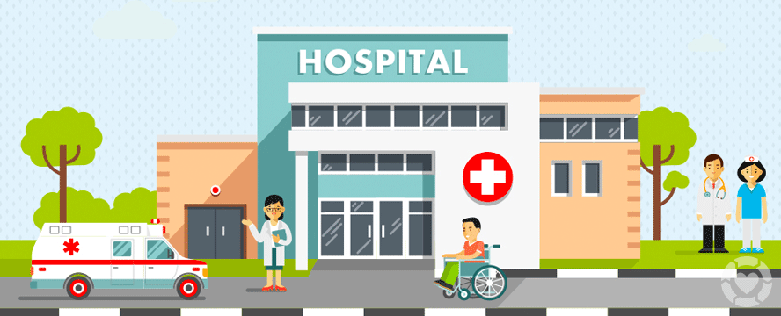



|  |
| --- |
| Last night, I could not sleep well. I kept thinking about Ario and Sara because |
| I needed their help. |
|  |
|  |
|  |
|  |
|  |
|  |
|  |
|  |
|  |
|  |
|  |
|  |

|  |
| --- |
|  |
|  |
|  |
|  |
| Finally, I thanked them for the unforgettable journey. |
|  |
|  |
|  |
|  |

**After writing**

|  |
| --- |
| **Read the individual writing again and complete the self-assessment checklist.** |

***Did I do the following?***

*(Please tick “✓”the box if you did it.)*

|  |  |
| --- | --- |
| 🞎 | Write about the **setting** (e.g. time & place) and **characters** of the story, |
| 🞎 | Write about the **plot** of the story, e.g. what happened, what they said/did. |
| 🞎 | Write about the **problem** and **solution**. |
| 🞎 | Useappropriate **tenses** to write the story. |
| 🞎 | Use **dialogues** in stories. |
| 🞎 | Use the **imperatives** to advice. |
| 🞎 | Use **adjectives** **of feelings** and **action verbs**. |

**Acknowledgements**

1. Information and images/pictures in this set of worksheets are taken from the following book published by the Inter-Agency Standing Committee (IASC):

***My Hero is You - how kids can fight COVID-19!***

<https://interagencystandingcommittee.org/iasc-reference-group-mental-health-and-psychosocial-support-emergency-settings/my-hero-you>

1. The video is presented by Dr. Linda Thomson to help students understand the book and can be accessed via the following link:

<https://www.youtube.com/watch?v=V29jbjPlEUA>

**My Hero is You - how kids can fight COVID-19**

**Worksheet**

**(Suggested answers)**

1. **Pre-reading activity (Accept any reasonable answers)**
2. **While-reading activity: First reading**

|  | **Character** | **Problem** | **Way to cope with problem** |
| --- | --- | --- | --- |
| (A) | **Sara and her mum** | 1. Sara’s mum is a scientist, but she cannot find a cure for the coronavirus. 2. Sara was upset because the virus was affecting her life. | 1. She asked Sara to take good care of herself and stay safe, so that she could focus on her work. 2. Sara decided to tell all the children in the world how to protect themselves so that they could protect everyone else. |
| (B) | **Salem** | 1. COVID-19 was affecting his life. 2. The city he lived in was crowded but not everyone stayed at home. 3. He missed the people he loved a lot, including his grandparents. | 1. In order to protect himself, he stayed at least one metre away from people, washed his hands with soap and water. He also coughed into his elbows if needed and wave to people instead of shaking hands. 2. He flew across the city with Ario and Sara to tell everyone to stay home/inside. 3. He chatted with grandparents on the phone and shared what he did every day. |
| (C) | **Ario** | He felt scared sometimes. | When he felt scared, he breathed very slowly to calm down. |
| (D) | **Sasha** | 1. Her dad/father was sick and she was worried that she might spread the virus. 2. She sometimes argued with her family because they stayed together all the time at home. | 1. She did the following in order not to spread the virus:  * keeping a distance from people * using words to show her care instead of hugging people * staying home  1. She had to be extra patient and extra understanding, and quick to say “sorry”. |
| (E) | **Leila** | She was afraid of the virus because people might die from it. | She followed Ario’s advice by imagining a safe place in her mind. This helped keep her calm and relax. |
| (F) | **Kim** | He had the virus himself and had recovered from it. | He kept a distance from his friends who cared about him. He believed that the most important thing friends could do was to protect each other. |

1. **While reading: Second reading**

|  |  |
| --- | --- |
| Questions | Character: Salem |
| Where did Salem live? | He lived near a desert next to pyramids. He probably lived in a Middle East country called Egypt. |
| What were his super powers? | * He knew how to protect himself and others from catching the virus. * He was eager to remind the people in the city to take care of each other best by staying home/inside. * He cared about his grandparents by talking with them on the phone every day.   Use two adjectives to describe Salem.  smart, caring, positive (Accept any reasonable answers) |

|  |  |
| --- | --- |
| Questions | Character: Sasha |
| Where did Sasha live? | She lived in a small village. It was a place in the countryside, where there were green trees, beautiful flowers, and birds flying in the sky. |
| What were her super powers? | * She knew a lot about social distancing. * Her father was sick and she had to stay home to avoid sharing the virus with others. * Although she was on wheelchair and unable to walk, she stayed positive and enjoyed her life with her family even though they had to keep a distance from others. * She had great patience and was willing to apologise when she made a mistake.   Use two adjectives to describe Sasha.  optimistic, patient, considerate (Accept any reasonable answers) |

|  |  |
| --- | --- |
| Questions | Character: Leila |
| Where did Leila live? | She lived in a camp which provided a temporary shelter for the homeless people. |
| What were her super powers? | * She knew how to keep herself safe from the virus. * She could cope with her fears/worries by imagining a safe place in her mind. * She gave support to her friends and joined Sara and Ario in the journey to make people know more about COVID-19.   Use two adjectives to describe Leila.  e.g. brave, helpful, hopeful, positive (Accept any reasonable answers) |

|  |  |
| --- | --- |
| Questions | Character: Kim |
| Where did Kim live? | He lived in a small town, which was near a snowy mountain and a stream. |
| What were his super powers? | * He could stay positive although he once had the coronavirus. * He had some good friends. They cared about each other. They understood that staying away from each other for a while could protect each other.   Use two adjectives to describe Kim.  positive, sociable, friendly, caring (Accept any reasonable answers) |

1. **The key message of this story is “heroes come in all shapes and sizes”. In short, anyone can be a hero, including ourselves. The super powers of the characters are in the boxes below. Explain the super powers by giving more details.**

**(Accept any reasonable answers)**

1. Know how to protect ourselves from COVID-19:

* stay at least one metre away
* wash our hands with soap and water
* cough into our elbows if we’re sick.
* wave to people instead of shaking hands

2) Show our love and care to our friends and relatives by:

calling them or sending them messages every day to show our love and care to them.



3) Sometimes, to protect our friends and family members, we have to:

stay away from each other for a while

5) Be brave to share our worries and keep calm:

* imagine a safe place in her mind when we feel sad or afraid.
* remember that many people cared about we and stay strong.

4) Be extra patient and understanding by:

getting along well with our family members at home, e.g. Do not quarrel with them and learn to say “I’m sorry.”

1. **Re-read Part 3 of the story “Sara and Ario met Salem” and underline the features of the story.**



Use **adjectives** and **action verbs** to describe feelings:

e.g. The children **cried out in joy** and waved at Sara and her Ario.

e.g. People were **amazed** by what they saw. The **waved** and **agreed** to go into their houses.

**Problem:**

What problem did the character face?

**Plot:** What did they say/ What happened?

The **simple past tense** to write about things that happened:

e.g. The children **cried** out in joy and **waved** at Sara and Ario.

The **past continuous tense** to show an ongoing past action which was happening at a specific moment:

e.g. As the sun rose, they landed in a lovely desert by pyramids, where a small group of children **were playing**.

Grammar items and language used in the story

**Characters:** Who did they meet?

**Setting:** Where did the story take place?



Use **adjectives** and **action verbs** to describe feelings:

e.g. The children **cried out in joy** and waved at Sara and her Ario.

e.g. People were **amazed** by what they saw. The **waved** and **agreed** to go into their houses.

The **imperatives** to give advice:

e.g. “**Go**, **tell** your families, we are safer inside!”

**Solution:** How did they solve the problem?

1. **Writing task (Accept any reasonable answers)**